Class Time:
Names:

Ch. 12: Regression Lab I
Student Learning Outcomes:
- The student will calculate and construct the line of best fit between two variables.
- The student will evaluate the relationship between two variables to determine if that relationship is significant.
Do the Experiment:
Use 8 members of your class for the sample. Collect bivariate data (distance an individual lives from school, the cost of supplies for the current term).
Distance from school | Cost of supplies this term

- Which variable should be the dependent variable and which should be the independent variable? Why?

- Graph “distance” vs. “cost.” Plot the points on the graph in 6. below. Label both axes with words. Scale both axes.
- Enter your data into your calculator or computer.
- Write the linear equation below, rounding to 4 decimal places.

a = ___________ b = ___________ correlation = _____________ n = _________

equation: = _______________________________________
Is the correlation significant? Why or why not? (Answer in 1-3 complete sentences.)

- For a person living 8 miles from campus , predict the total cost of supplies this term.

For a person living 80 miles from campus , predict the total cost of supplies this term.

- Obtain the graph on your calculator or computer. Sketch the regression line below.
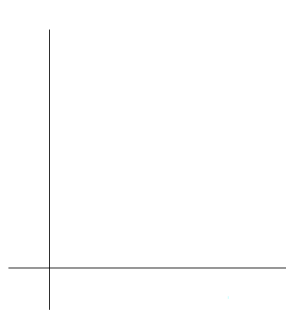

- Questions (Answer each question with 1 - 3 complete sentences.)

  - Does the line seem to fit the data? ______________Why?

  - What does the correlation imply about the relationship between the distance and the cost?

- Are there any outliers? ___________ If so, which point is the outlier? _____________

- Should the outlier, if it exists, be removed?____________ Why or why not?

